**Laboratory Six MOSFET**



**Javier Jesús Macossay-Hernández**

**EE348L – Electronic Circuits**

**University of Southern California**

**Professor Susan Schober**

**Introduction**

MOSFETs is a type of transistor used for amplifying or switching electronic signals. Additionally, small signal analysis is done to have a guess of the transistor’s behavior and to calculate the gain on the simple transistor amplifiers. Two amplifiers were built, common-source and common-drain amplifiers. Small signals resulting from large signals input and load influences were analyzed as well.

Exercise 1

**Procedure**

On Exercise 1, the following circuit was built. The gain was calculated for Id = 1mA and the input signal to the circuit was a sinusoidal signal of 50 mV with 10 kHz. Vdd = 5V.

**Data**

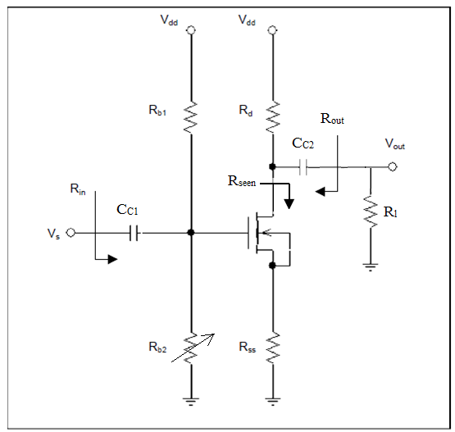

Circuit Schematic

|  |  |  |  |  |  |  |
| --- | --- | --- | --- | --- | --- | --- |
|  | RD (Ω) | RSS (Ω) | RB1 (Ω) | RB2 (Ω) | CC1 (μF) | CC2 (μF) |
| Values | 1487 | 501 | 21620 | 25060 | 5 μF | 5 μF |

**Questions**

The gain is larger than the one from the calculations and SPICE simulations because we used a simplified model for the hand analysis.

**Discussion**

From the actual circuit, the Vin = 130 mV peak-to-peak voltage and a Vout = 480 mV. As a result, the gain is 3.63.

Exercise 2

**Procedure**

On Exercise 2, the gain from Exercise 1 was doubled. The theoretical equation for gain used is:

AV = -

**Discussion**

By analyzing the equation, Rd should be incremented or Rss should be decreased. In order to obtain a gain twice the value from Exercise 1, 7.18, we will make Rss = 110 Ω to obtain a Vout of 934 mV.

Exercise 3

**Procedure.**

On Exercise 3, we would use circuit from Exercise 1. The gain was calculated using when different values for resistances were used. 100 kΩ, 10 kΩ, 1kΩ, and 100 Ω.

**Data**

|  |  |  |
| --- | --- | --- |
| **Theory Value for R (Ω)** | **Real Value for R (Ω)** | **Gain** |
| 100k | 98.67k | 3.44 |
| 10k | 9.89k | 3.44 |
| 1k | 995 | 1.29 |
| 100 | 99.3 | 0.5 |

**Questions**

The results of this analysis match with the results of pre-lab Exercise 4, therefore they confirm our expectations.

**Discussion**

The gain gets influenced as the value of RL gets closer to the value of RD. As RD decreases, the resistance goes to zero. As a result, the gain dropped.

Exercise 4

**Procedure**

On Exercise 4, the following circuit was built. The gain was calculated for Id = 1mA and the input signal to the circuit was a sinusoidal signal of 50 mV with 10 kHz. Vdd = 5V.

**Data**

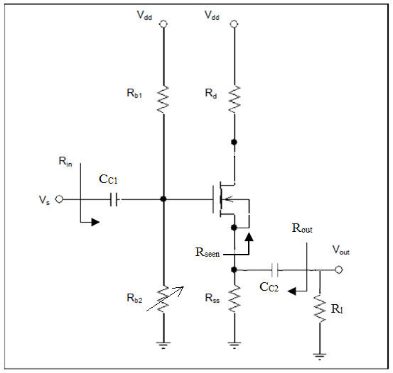

|  |  |  |  |  |  |  |
| --- | --- | --- | --- | --- | --- | --- |
|  | RD (Ω) | RSS (Ω) | RB1 (Ω) | RB2 (Ω) | CC1 (μF) | CC2 (μF) |
| Values | 1487 | 501 | 21620 | 27100 | 5 μF | 5 μF |

**Questions**

The result, in this case the gain, yields to what expected from the circuit.

**Discussion**

In this exercise Vs = 130 mV peak-to-peak and Vout = 142 mV. As a result, gain is equal to 1.09.

Exercise 5

**Procedure**

On Exercise 5, the load resistance was increased from 100 Ω to 100 kΩ. As resistance was increased, the gain increased because the resistance becomes closer to become an open circuit. Therefore, it affects the gain less.

**Data**

|  |  |  |
| --- | --- | --- |
| **Theory Value for R (Ω)** | **Real Value for R (Ω)** | **Gain** |
| 100k | 98.67k | 1.016 |
| 10k | 9.89k | 1.048 |
| 1k | 995 | 1.033 |
| 100 | 99.3 | 0.613 |

**Questions**

The result yields to what expected from the circuit.

**Discussion**

For RL smaller than RSS the gain drops because it is directly proportional to RSS || RL. In the common-drain gain equation, RSS is replaced by RL and gmRL decreases smaller than 1. As a result, the gain drops.

AV =

**Conclusion**

The results clearly agree with the objective of the lab that is analyze amplifiers and its concepts. In general, the results obtained from the laboratory experiments yield to the results from the hand calculations and the SPICE simulations because the common-drain and common-source amplifiers behaviors can be considered successful according to the experiments.